CHEM106 Section 001 Problem Set 3 Name: _______________________
Due Date: November 20, 2019

- (15 points) As part of your senior research project, you have identified a novel bacterium that is capable of degrading the coat protein of the H1N1 virus. The protease responsible for the antiviral effect hydrolyzes the peptide bond between phenylalanine and alanine in the substrate. Analysis of the protein shows that it is a serine protease. Draw the reaction mechanism for this reaction. You must show all atoms of the substrate and the side chain atoms of the catalytic amino acids in the enzyme in your answer. You must clearly show the arrows indicating the formation/dissolution of bonds in your answer.

- (12 points) Draw the Haworth projections of:
  - Maltose
  - Lactose
  - Cellotriose
  - Sucrose

- (10 points) A generalized summary of the Tollen’s test for Reducing Sugars is below:

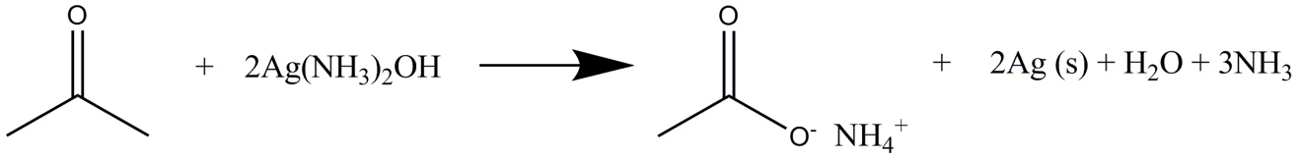
H

Which of the following sugars would give a positive result (silver mirror) for the Tollen’s test?

- Sucrose
- Lactose
- α-D-fructose
- β-D-glucose
- Trehalose

- (8 points) Draw the structural formulas of the reactants and products of the saponification (NaOH catalyzed) of a triacylglyceride possessing palmitic, lauric and oleic acid esters.

